Optional File 45_region_carsvc_powertrain_prop.csv
May 23, 2026
Definition of the Input File
VisionEval (https://visioneval.github.io/docs/model-inputs.html) explains that this input file is optional. It is only needed if the user wants to modify the powertrain proportion of car services. This file contains six attributes:
- CarSvcAutoPropIcev: Proportion of car service automobile travel powered by internal combustion engine powertrains
- CarSvcAutoPropHev: Proportion of car service automobile travel powered by hybrid electric powertrains
- CarSvcAutoPropBev: Proportion of car service automobile travel powered by battery electric powertrains
- CarSvcLtTrkPropIcev: Proportion of car service light truck travel powered by internal combustion engine powertrains
- CarSvcLtTrkPropHev: Proportion of car service light truck travel powered by hybrid electric powertrains
- CarSvcLtTrkPropBev: Proportion of car service light truck travel powered by battery electric powertrains
For example, the data below suggest that the proportion of car service automobile travel powered by internal combustion engine powertrains in Virginia in 2024 is 0.953187025, while the proportion powered by hybrid electric powertrains is 0.03204121. For each year, the values within a group must sum to 1; otherwise, VisionEval may crash.
When saving the CSV file, Excel may automatically truncate values after the ninth decimal place. Therefore, the row totals should be checked to ensure that the sum remains 1.
Possible Scenario
Changes to this file would likely be useful for analyzing the impacts of changes in the powertrain composition and vehicle mix of automobiles versus light trucks used for car service within the model region. For example, modifying the shares of ICEV, HEV, and BEV vehicles could affect outcomes related to emissions, energy consumption, fuel use, and operating costs. The document Task 7.2 Simplified Scenario Development guide available at A Playbook for Simplified Approaches for Creating Scenarios in VisionEval explains that this file can be used to modify the proportion of powertrains and vehicle mix of autos vs light trucks for car service in the model region. The powertrain classifications are ICEV (internal combustion engine), HEV (hybrid electric), and BEV (battery electric) for the automobiles and light trucks used for car service. This file specifies the share of total VMT for any specific year for each of these powertrain types rather than assign specific vehicles.
Method Used for Virginia
Based on the extrapolation method below, 2024 and 2045 values were estimated using 2021–2023 data.
Several steps were used to develop these data for the 2024 and 2045.
- Source: Motor Vehicle Registration Data by Energy Source: 2016-Present, Virginia Open Data Portal
  - URL: https://data.virginia.gov/dataset/motor-vehicle-registration-data-by-energy-source-2016-present?utm_source=chatgpt.com
  - Location: Organizations–U.S. Department of Transportation–Motor Vehicle Registration Data by Energy Source: 2016-Present
  - Search Keyword: Energy Source
  - Related Sheet: Not Applicable

- Year that the Data Reflect: 2024 (The 2024 value was projected using data from 2021 to 2023.) 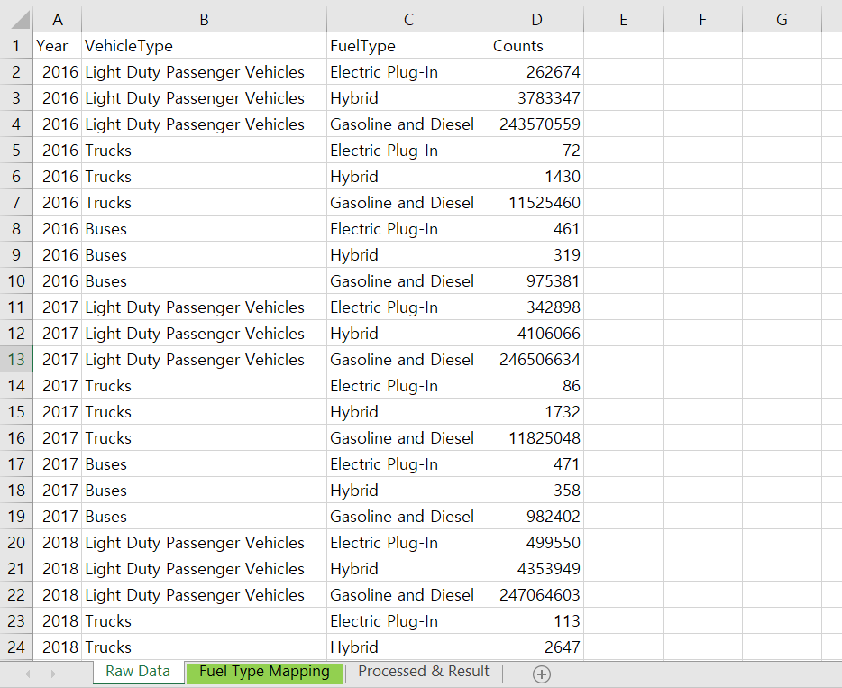

- How the Data Were Processed
  - Fuel Type Mapping
Fuel Type (NTD) | Category
Gasoline and Diesel | ICEV
Hybrid | HEV
Electric Plug-In | BEV

  - Car Service Assumption: The number of car service vehicles (e.g., Uber, Lyft) is not available from any known sources. Therefore, the powertrain proportion for car service vehicles was assumed to be the same as that of registered vehicles in Virginia.
  - Vehicle Type Mapping: Vehicle types need to be categorized into automobiles and light trucks. However, no data source is available that provides powertrain proportions disaggregated by vehicle type. As a result, the powertrain proportions for automobiles and light trucks were assumed to be equal.
  - Base Year and Target Year Values Projection: At first, both the 2024 base year and the 2045 target year values were projected using the compound annual growth rate (CAGR) calculated from 2021 to 2023 data. However, the number of electric vehicles was significantly overestimated due to their high initial adoption rate. 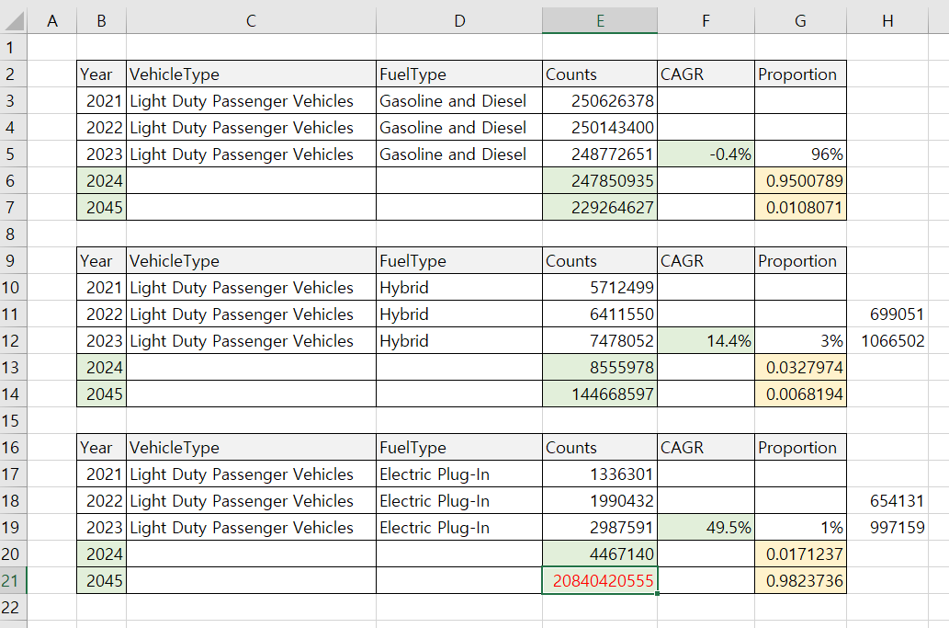
Therefore, the total number of light-duty passenger vehicles was projected by year first, and then the number of gasoline and diesel vehicles was estimated based on the CAGR.
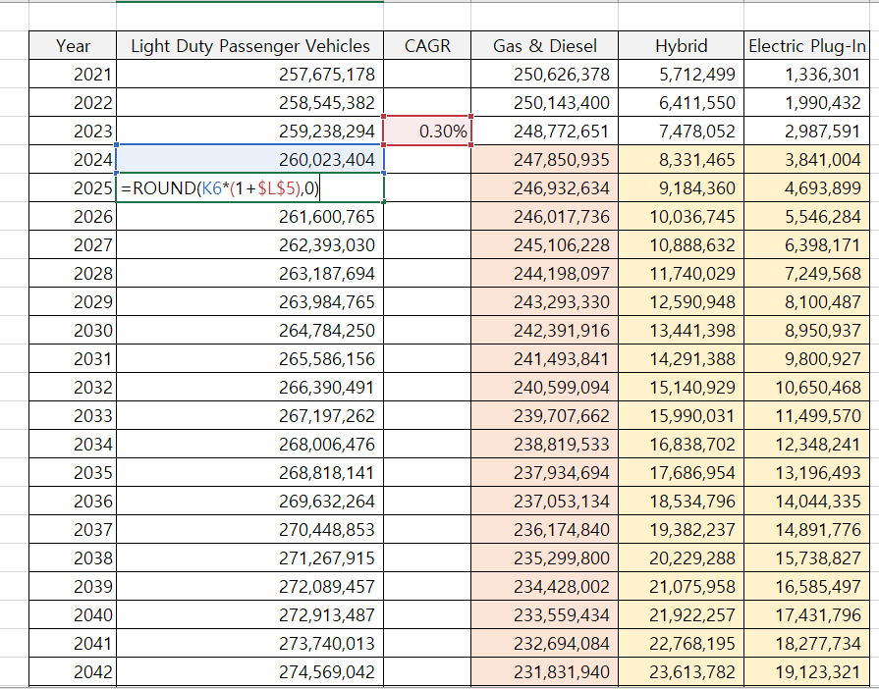 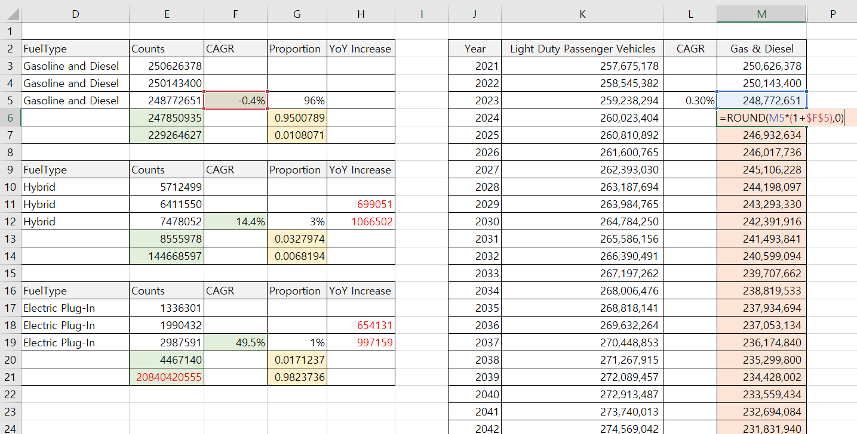
Given that the year-over-year increases in hybrid and electric vehicles are nearly identical, the number of new vehicles added each year was assumed to follow a 1:1 ratio between the two types. (Refer to the figure above.) Then, the number of hybrid and electric vehicles by year was estimated by subtracting the number of gasoline and diesel vehicles from the total number of light-duty vehicles, and incrementally adding an equal number of new vehicles to each category based on the previous year's values. Lastly, the proportions of each vehicle type were calculated based on the estimated numbers.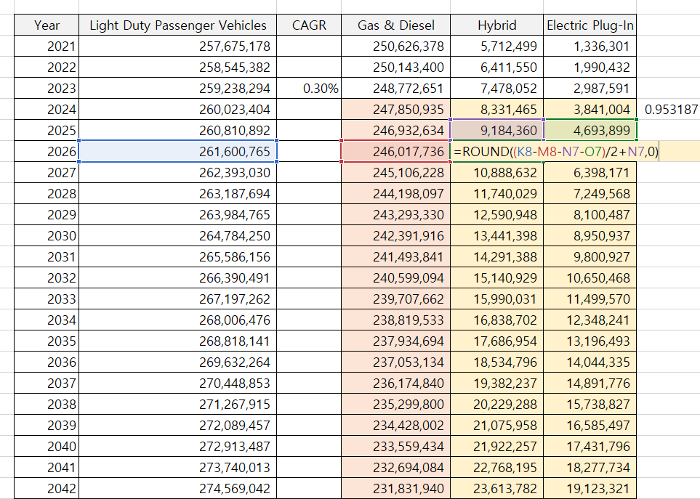

  - Final Result

